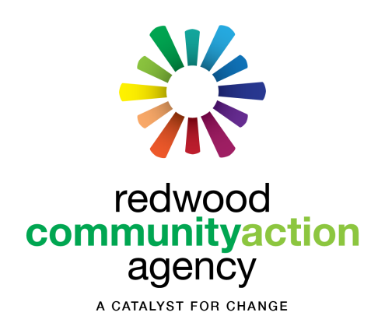
Redwood Community Action Agency
904 G Street, Eureka, CA 95501
Phone 707-269-2001

Small Purchase Procurement Request for
Design, Drafting, Cost Estimating and Architectural/Engineering Certification Services

OPEN DATE: Tuesday 6/2/2020 DUE DATE: Friday 6/12/2020 by Noon
FOR INFORMATION CONTACT: Kari Love, kari@rcaa.org (707) 269-2022
Project Description: The Murray Duplexes were built in 1945 and consist of 10 nearly identical Duplexes. The owner, Redwood Community Action Agency (RCAA), purchased, maintains and manages these duplexes to provide affordable housing to low-income community members. RCAA is working with the County of Humboldt to submit a grant application to secure funding for the rehabilitation and reconstruction of some or all the units. The duplexes are affordable housing; the goal of the project is to improve the quality and longevity of the apartment complex while staying within the project budget. The physical location is 1455 Murray Rd. McKinleyville, CA APN: 511-101-022. This procurement request is available through the RCAA website www.rcaa.org under News & Events.
Scope of Work:
- Meet (virtually if needed) with property owner, surveyor and owner’s agent to discuss project goals.
- Conduct initial inspection; determine if additional access to subfloor and attic areas are needed. Coordinate with owner to get access if needed.
- Inspect and measure an existing building interior:
  - Measure 1 of the 10 duplex building’s interior and exterior;
  - Document existing construction of the unit. Documentation will include crawlspace clearance, Subfloor framing dimensions and materials, wall construction dimensions and materials, roof framing and description of existing insulation.
  - Measure exterior dimension of all the units. Determine if units are comparable in size and construction based on exterior measurements. Note significant inconsistencies.
- Using plot plan developed by the surveyor develop as-built plans for the unit measured in detail. (Scope of survey work available for review/ work currently being completed).
- Develop Draft plans for the reconstruction of one unit. Note: The Humboldt County Building official has authorized an expansion of the existing building footprint to allow the reconstruction to meet current occupancy standards including doorway clearances, minimum bedroom sizes and closets for bedrooms. The plans for the reconstruction of the unit shall include:
  - A duplex unit that utilizes universal design principals
  - ADA compliant ingress/egress.
  - Enough space in the unit to allow for ADA compliant kitchen and bathroom facilities
  - Determination on use of the existing foundations. Consider ventilation improvements.
  - Electrification of the unit’s heating (Air source heat pump), cooking facilities (electric range with ventilation), and hot water heater -either on demand or tank on a timer. Mechanical systems should be included in the building envelope.
  - If possible, design should consider reduced sound transmission between duplex units.
- Prepare a cost estimate for the unit reconstruction and required site modifications.
- Develop design for adequate parking on site and streets. Consider ADA accessibility and allowances for the addition of photovoltaic array and/or electric vehicle charging stations later.
- Review PNA/current conditions and develop rehabilitation costs for units that will not be reconstructed.
- Review Draft Plans and cost estimates with owner and project manager(s). Based on discussion, prepare final building plans.
- Provide title 24 energy report.
- Propose a scope of work that will fit within the funding limitations for the project. Scope of work will include reconstruction of one or more units and the rehabilitation of all other units.
- Finalize reconstruction and rehabilitation plans with owner.
- Provide certification of a licensed engineer or architect that the plans are “Bid Ready” by August 1, 2020.
Attachments provided on rcaa.org website:
- 2019 Physical Needs Assessment (PNA)
- Survey and Plot Plan scope of work (finished products available by time of contract start)
- Rough Draft as-built drawings
Procurement Timeline:
6/2 Release of Procurement Request
6/5 Deadline for questions or requests for on-site visit
6/12 Submittals due by noon (proposals accepted ASAP, open until filled)
6/15 Contracts awarded
Benchmarks:
#1: 7/10 Draft Plans and cost estimates.
#2: 7/17 Provide scope of work that fits within the funding limitations for the project.
#3: 8/1 Certification of a licensed engineer or architect that plans are “Bid Ready”

For questions please call Andrew at 707-445-7541 or Kari at 269-2022 or use the emails below.
Responses to this procurement request should be emailed to kari@rcaa.org and awhitney2@co.humboldt.ca.us or faxed to 707-445-0884 Attn: Kari Love. They may also be dropped-off or mailed to RCAA at 904 G St. 95501 Attn: Kari Love.
Responses are required to include: Name of Firm; Contact Name, Signature, and Date; Contact Phone #(s), email and address; and cost to complete proposed work.

