AFACTR AMERICORPS SEEKS MEMBERS FOR THE 2014-2015 12 MONTH TERM OF SERVICE

Location: HUMBOLDT COUNTY – Blue Lake/Manila, Eureka, Fortuna, McKinleyville, Redway, Rio Dell and Willow Creek.

AFACTR (Assisting Families to Access Change through Resources) AmeriCorps is a program administered by Redwood Community Action Agency and is currently accepting applications. Member positions are scheduled to begin on September 16, 2014. All positions are full-time (1700 hours) for a 12 month term. Applications will continue to be accepted until all positions are filled. There will be members hired and placed at a site in Humboldt County. Apply now!
The mission of the AFACTR AmeriCorps program is to strengthen Humboldt County communities and families through collaborative work with Family Resource Centers and Child Welfare Services. By providing families with basic case management and increasing the awareness of local resources members are helping to: reduce family isolation, create healthy families and improve outcomes of children and families who are in need and/or at risk for child abuse. The primary purpose of the program is to help prevent child abuse in Humboldt County.

AFACTR AmeriCorps Members will:
*Provide families with preventative case management
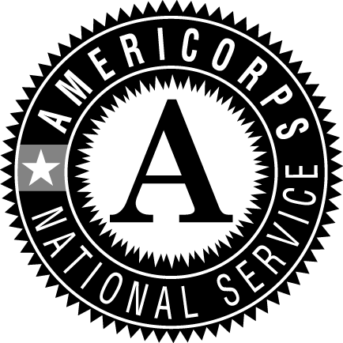*Make referrals for families to needed local resources
*Support positive family and community connections for children
*Teach Nurturing Parenting Lessons
*Participate in national service days

Minimum requirements:
• Must be 21 years of age or older
• U.S. citizen or legal resident
• High School Graduate and some college
• Have good communication skills
Preferred qualifications include:
• Experience working with the public
• Social service experience
• At least 2 years college course work
• Proficient or bi-lingual in English and Spanish for select sites
TO APPLY: go to my.americorps.gov and fill out an application. Then apply to AFACTR AmeriCorps.
If you have questions please contact the AFACTR AmeriCorps Project Coordinator, Lynn Kerman, at
afactr@rcaa.or or call (707)269-2020. VISIT US ONLINE at http://rcaa.org/division/community-programs/ program/afactr-americorps.

Compensation and benefits: All members receive a yearly living allowance ($16,750-amount can vary) which is paid twice monthly in equal increments throughout the term, an education award of $5,550 (amount can change per term) for completing a 12 month, 1700 hour full-time term of service and student loans can be put in forbearance during your term of service. Program start date is September 16, 2014. Other benefits include: basic health insurance, child care benefits if eligible, training, member development, a very supportive network of members and staff and being part of a nationwide group of hundreds of AmeriCorps members making a difference in our communities.

