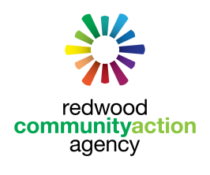
ARE YOU ELIGIBLE FOR AN ENERGY
REBATE???
WITH HELP FROM
Redwood Community Action Agency
YOU CAN GET ONE

Low– income households spend 14% of their income on energy compared to
3.5% spent by other households.

Need help paying your energy bill? RCAA’s HEAP PROGRAM IS HERE TO HELP! The HEAP program offers income-qualified households a credit on their PG&E bill or with the purchase of propane, kerosene, or wood once per year.
2018 INCOME LIMITS – DO YOU QUALIFY??

 |  | 2018 INCOME GUIDELINES
 | HOUSEHOLD SIZE |  | GROSS MONTHLY INCOME LIMIT
 | 1 |  | $2,097.98
 | 2 |  | $2,743.52
 | 3 |  | $3,389.05
 | 4 |  | $4,034.58
 | 5 |  | $4680.12
 | 6 |  | $5325.65
 | 7 |  | $5446.69

If you qualify, call for HELP TODAY!
CALL 707-444-3834 TODAY to schedule an appointment

